UGANDA
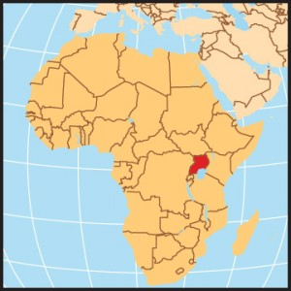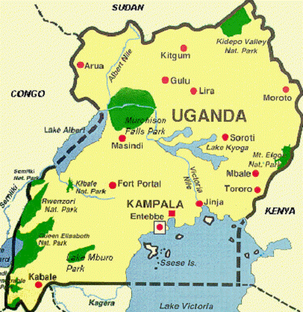
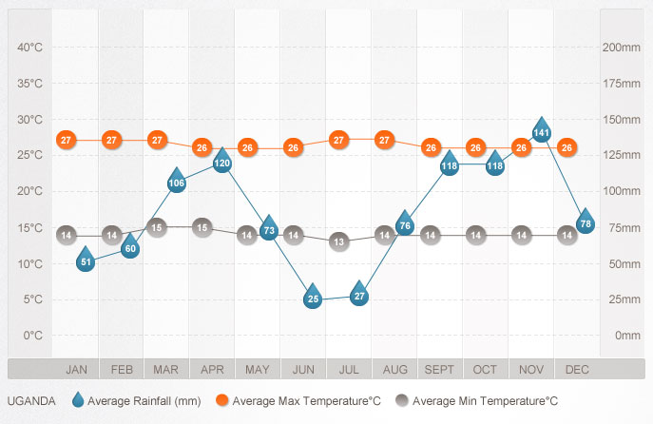

Uganda, a landlocked country in East Africa, consists of savanna plateau with mountains and lakes. "The pearl of Africa," wrote Winston Churchill of this former British protectorate that embraces Lake Victoria, source of the White Nile, and the misty Ruwenzori Mountains in the Bwindi Impenetrable Forest National Park—a home of the endangered mountain gorilla. There are 5 World Heritage listed parks amongst the twelve in Uganda including Murchison Falls and Queen Elizabeth National Park which is excellent for safari spotting and activities. Lonely planet, the world’s largest travel guide book and digital media publisher has named Uganda the number one tourism destination to visit in 2012.

Population: 26,907,000
Capital: Kampala; 1,246,000
Area: 241,139 square kilometres (93,104 square miles)
Language: English, Ganda or Luganda, many local languages
Religion: Roman Catholic, Protestant, indigenous beliefs, Muslim
Currency: Ugandan shilling
Life Expectancy: 44
GDP per Capita: U.S. $1,200
Literacy Percent: 70

21 THINGS YOU MIGHT NOT HAVE KNOWN ABOUT UGANDA
- Very Good Hospitality: – Ugandans are known for their hospitality and style of welcoming guests. You should go to the village area of Uganda to see how warmly they welcome you. The people and especially the children will start screaming with joy when they see the guests, they will hug you and give you a handshake.
- Best Tourist Location of 2012: The lonely plan selected Uganda as the best tourist attraction country in 2012. The reports stated that nearly 1 million tourists across the world visit Uganda every year.
- Tree Loving Nation: – There is a rule in Uganda regarding cutting of trees. The rule is, if you cut one tree, then you will need to plant three trees. Well you may find this rule quite weird but this rule is really present in Uganda.
- One of The Best Bananas, Pineapples and Avocados Producing Country: – Banana is a very famous fruit in Uganda. People make various types of recipes from banana. You can even get wine produced from banana.
- Home of Gorillas: – The study stated that there are just 750 mountain gorillas in the world. Being a home of these gorillas, you can see gorillas in Bwindi and Mhahinga National parks in Uganda. And these gorillas are present only in a few national parks in Uganda and some other African countries. These gorillas will not be found in any other zoo of the world.
- Pearl of Africa: – Uganda was referred as a pearl of Africa by Winston Churchill because of its magnificence.
- Low GDP: – As Uganda is one of the poorest countries, the economic condition of many people in the country is not stable. A study has stated that nearly half of the population in the country survives on less than a dollar every day but the people are very happy and cheerful.
- People Love Bicycle: – Ugandan people love using bicycles.
- Huge Amount of Alcohol Consumption: – Uganda has been ranked as one of the biggest alcohol consuming nation in the world. Despite poverty, people consume alcohol a lot.
- The Youngest Country in The World: – Astonishing fact is that nearly 50% population in Uganda is under the age of 14. With such low age, it is world’s youngest country. The average age of Ugandan’s is just 50 to 60 years. More Fun Facts About Uganda
- In terms of size, Uganda has the same size as Oregon State but comparatively, there is a very wide difference in the population with Uganda having a population of 34.5 million and having a population of mere 3,871,859
- There are 2 different dry seasons in Uganda: between December and February and between June and August every year. The average temperature is about 26 degrees centigrade, with a maximum of 18-35 degrees and minimum of 8- 23 degrees depending on the part of the country. Rainfall ranges between 500mm to 2500 mm and the relative humidity is 70% -100%
- If you are presented with a meal of pan fried grasshoppers in Uganda, consider yourself a special guest because it is one of the favourite treats in the country
- “I need to make a short call” is a sentence that is usually used to mean going to rest room in Uganda
- Uganda is the place to visit if you want to find the endangered mountain gorillas which are currently less than 750 in population in the world. They are found in these locations: the Bwindi National Park, Parc de volcanoes National park in Rwanda, and the Virunga in Congo.
- About 10 million people in Uganda have mobile phones (approximately one-third of the population)
- Matooke is a very popular food in Uganda and a favourite food for most people in the country. It is a plantain type of banana that is prepared by cooking in banana leaves.
- Women are the civil engineers and contractors in Uganda because women do most of the work needed in building a mud house while the men only install the roof.
- The favorite sport in Uganda is Soccer in x 7/10/2016 21 Interesting Facts About Uganda You've Never Heard http://buzzkenya.com/factsaboutuganda/ 6/14 African Ubuntu Safaris Still Haven't Booked Your African Safari? We Can Help You Today! which the country ranks number 24 in Africa and 93 in the world.
- The Daily Monitor is a Ugandan newspaper that is published in English. It is one of the few newspapers in Uganda that publishes unbiased news report for latest news events in Uganda.
- Boda-bodas is the name given to Ugandan motorcycle transport because they were formerly used to transport people across the “no-mansland” ( a patch of land between the Kenya/Ugandan border posts.

GREETINGS
Men greeting Men – A handshake is appropriate in most situations. Handshakes tend to be energetic and very often linger a bit. To express extra deference, the hand-shaker may lightly grip his hand-shaking forearm with the opposite hand. Many times men will hold hands with other men, and often the handshake is prolonged into this hand-holding. This does not have any implication on their sexual preferences; it's just a sign of friendship and closeness.
Women greeting Women – A handshake and/or nod of acknowledgment is appropriate in most situations. If you would like to show great respect you may also place your left hand over your right elbow/forearm when handshaking. Many times women will hold hands with other women, and often the handshake is prolonged into this hand-holding.
Meetings between Men and Women – Appropriate greetings depend on the nature of the relationship and region. A handshake is usually appropriate but it is best to wait for the woman to extend her hand, otherwise a bow or a nod of acknowledgment will suffice.
Note: Always use your right hand when shaking hands.

COMMUNICATION STYLE
- Ugandans tend to communicate more indirectly than directly.
- Stories, proverbs, and the like are common means of expressing a point indirectly and require the implicit knowledge of the listener.
- Greetings and a good amount of small talk almost always occur before talking about business.
- Feelings tend to not be accurately expressed between adults and sometimes one can get the feeling of being fawned upon with false happiness, or being lectured by a false sternness.
- Humour plays a big role in communicating and most Ugandans enjoy a good joke. However, it is best to avoid sarcasm as it may not translate well, if at all.
PERSONAL SPACE AND TOUCHING
- Personal space tends to be very minimal in Uganda. People often talk very close to each other and less than an arm’s length of space is common.
- On public transportation, personal space is limited to non-existent. It is common to see people crowded into a bus or taxi with no space in between. This tends to be the case more in rural areas vs. urban.
- When two people of the same sex are talking, touching is acceptable. It is common to touch the hands, arms, and shoulders.
- When two people of the opposite sex talk there is very little to no touching. The only appropriate touch is usually a handshake.

EYE CONTACT
- Generally, people prefer indirect eye contact. This does not mean you can’t look at somebody directly, but continuous eye contact during conversations is not a must.
- Overly direct eye contact can be considered aggressive by some.
- Women and children often will look down or away when conversing with men or with elders.

VIEWS OF TIME
- In most situations, Ugandans are not overly concerned with being punctual. People are expected to arrive within the first hour or two after the appointed time.
- The higher the status of the person, the more they are excused of lateness. Also, it tends to be that the more prestigious the event the later guests will arriving. This usually applies to both social and business meetings.
- Punctuality tends to be more valued in business situations.

GENDER ISSUES
- Uganda is going through a transition when it comes to gender roles; however, it is still a male dominant society.
- In most rural areas women will most likely be housewives. They will be expected to cook, clean, do they laundry and take care of the children, as well as work their land. Once married, the woman is transferred from her original family to the man's and takes on his clan. Marriage can be at a very young (early teens), but seems most common in the late teens. Also there is a transfer of "bride wealth" from the man to the woman's family. Polygamy is generally acceptable as well.
- In most rural areas, women have to wear clothing that covers the legs. Showing too much leg can result in a woman being called the local word for "whore".
- In urban settings it is more likely to find women who work and have a career. Although opportunities are becoming more varied, salaries and room for growth tend to be limited.

GESTURES
- When gesturing or beckoning for someone to come, you should face your palm downwards and make a scratching motion with the fingers.
- It is rude to point at people as pointing is reserved for dogs, so usually the whole hand/arm is used.
- Holding the palm upwards and then motioning in a small flick downwards (like throwing a yo-yo) has a variety of vague meanings. It could be questioning "what's up?" " What?"; apologizing "Sorry, what can I do?"; filler "You know."
- Pointing fingers upwards and rubbing the thumb along the fingertips is the sign for money.
- Special traffic gestures when trying to hail a taxi: Pointing straight upwards (repeatedly for emphasis): I'm going far. Pointing down: I just want to go a little ways (rarely used, because then they don't pick you up. Hand flat, open towards the ground about waist-height: I'm going a medium distance.

TABOOS
- Walking over versus around any bowls or pots (especially those containing food)is considered rude.
- Spending time in silence versus conversation is often times also interpreted as rude.
- Men almost always wear long pants, even in the hottest weather; shorts are a sign of being a child.

LAW & ORDER
- The legal drinking age is 18 and is not heavily enforced.
- Penalties for possession, use, or trafficking in illegal drugs in are severe, and convicted offenders can expect long jail sentences and heavy fines.

OTHER STUFF
- Speak slowly and enunciate -- most Ugandans have difficulty understanding fast, strung-together English.
- Local greetings are a bit difficult to learn but many people in rural areas will greatly appreciate this small effort.
- If you look like a foreigner you are likely to be overcharged for most things. If you can afford this, it doesn't really matter, just pay. If you can't or would like the right price, try bargaining by at least halving the price they gave you.

