PEOPLE OF TANZANIA
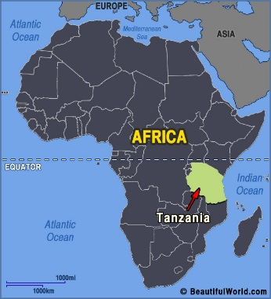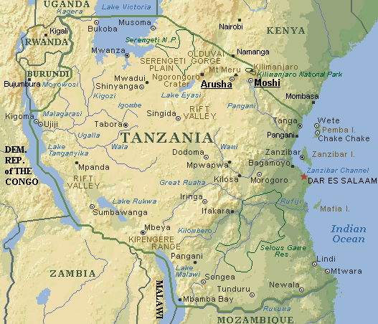
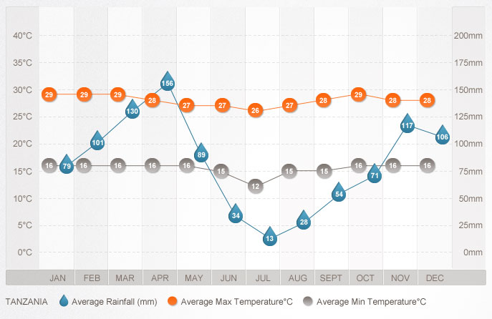
THE FACTS
The current estimated population of Tanzania stands at over 43 million people. The distribution of people across the vast landscape is quite uneven with more than 80% located in rural areas, particularly those that receive reliable rainfall. Rural to urban migration continues at a fast pace with large numbers of people seeking employment in the main cities of Dar es Salaam, Arusha, Mwanza and Dodoma.
Given over 120 ethnic groups, it is impossible to visit and learn about each of the traditional cultures of Tanzania in one visit. However, visiting a selection of Bantu-speaking people, Nilotic pastoralists, and the Bushman hunter-gathers in their traditional lands, gives you a wonderful glimpse into local Tanzanian life.
OFFICIAL LANGUAGE: Kiswahili or Swahili (official), Kiunguja (name for Swahili in Zanzibar), English (official, primary language of commerce, administration, and higher education), Arabic (widely spoken in Zanzibar), many local languages also spoken.
MAJOR RELIGION(S): Mainland - Christian 30%, Muslim 35%, indigenous beliefs 35%; Zanzibar - more than 99% Muslim.

MAJOR ETHNIC GROUPS: Mainland - African 99% (of which 95% are Bantu consisting of more than 130 tribes), other 1% (consisting of Asian, European, and Arab); Zanzibar - Arab, African, mixed Arab and African.

MAIN TRIBES/PEOPLE

MERU PEOPLE
The Meru people, or waMeru, are a Bantu-speaking people who settled at the base of Mount Meru over three hundred years ago. They settled in the forested area on the southeastern slopes of the mountain and developed a strong agricultural economy along with livestock keeping. It is believed that the waMeru practiced a traditional style of permaculture, and it is possible to witness some of these activities during a visit to the waMeru homeland.
MAASAI PEOPLE
The Maasai are a Nilotic ethnic group (very different from Bantu-speaking ethnic groups) of semi-nomadic people located in northern Tanzania and southern Kenya. Because of their unique culture and customs, they are among the best known of African ethnic groups. A very proud people, Maasai warriors and elders enjoy sharing their knowledge and experience with visitors, as long as one of their own is guiding and translating.
The Maasai have an extensive system for nurturing the mind, body and spirit using medicinal plants combined with expert healers skilled in traditional psychology and spiritual healing practices. A visit to Maasailand can include learning and experiencing these practices from Maasai people themselves.
HADZA PEOPLE, THE BUSHMEN OF LAKE EYASI
The Hadza, or Hadzabe, inhabit an area of north-central Tanzania around Lake Eyasi in the central Rift Valley and into the neighboring Serengeti Plateau. There are very few Hadzabe remaining on this land, most likely just under 1000 people, of which less than 400 continue to live a hunter-gatherer lifestyle.
While the Hadzabe speak a language with clicking sounds in it, their ethnic group appears to be genetically unrelated to the Khoisan people of southern Africa. Due to pressure from neighboring groups encroaching on their land and impact from insensitive tourist operations and trophy hunting activities, it is very difficult to witness the authentic Hadzabe way of life. Together with patience and an open heart, you may be fortunate to experience a traditional family gathering and hunt with a group of Hadzabe.
DATOOGA PEOPLE, BARBAIG TRIBE
The Datooga are a pastoralist Nilotic people of north-central Tanzania south of Ngorongoro Crater. There are seven Datooga tribes, the Barbaig being one of them. The Barbaig people whose traditional culture is still unchanged and unspoiled, are highly-skilled in metalwork. The Maasai traditionally traded livestock with the Barbaig in order to obtain the metal tips they needed for their spears. A visit to Barbaig communities can include seeing metal workers in action and an opportunity to obtain beautiful jewelry, some of which is fashioned from car spri
IRAQW PEOPLE
The Iraqw are a Cushitic people of the Arusha and Manyara Regions of north-central Tanzania, near the Rift Valley wall and south of Ngorongoro Crater. The language is distinctive from their Bantu and Nilotic neighbors and resembles an Arabic sound. The areas surrounding Karatu town in Arusha region is Iraqw homeland and visitors can witness their locally developed intensive cultivation techniques.
Traditionally in conflict with the Maasai, Iraqw homesteads included underground tunnels – aasimo -- in which to hide. Visitors can see these elaborate structures during a visit to the Karatu area.
10 THINGS YOU MAY NOT HAVE KNOW ABOUT TANZANIA
- Tanzania is just a little bit more than twice the size of California.
- Over 120 languages are spoken in Tanzania. Most of these are Bantu languages, a category of over 535 languages and dialects that are spoken throughout Africa.
- Mpingo trees (a.k.a. Africa blackwood trees, commonly seen in Tanzania) are the most expensive hardwood tree in the world.
- The world’s earliest human skull was found in the Olduvai Gorge in Tanzania.
- Tanzania has the largest concentration of wildlife animals per square kilometer, with more than 4 million wild animals and representatives of 430 species and subspecies.
- Once upon a time, the ancestors of the wild elephants that live in Tanzania today didn’t roam on the land, they swam in the water! Dugongs were sea cows that lived in Tanzania in sheltered waters 55 million years ago. They grew about 3.5 meters in length and lived to be about 70 years old.
- Mount Kilimanjaro is located in Tanzania. At 19,341 feet above sea level, it is the largest mountain in Africa.
- Tanzania shares it national anthem with South Africa and Zimbabwe. It’s titled “Mungu Ibariki Afrika” (God Bless Africa) and was composed by Enock Sontonga.
- Tanzania is divided into 26 regions (mikoa), 21 on the mainland, 3 on Zanzibar Island and 2 on Pemba Island. These are further divided into 99 districts (wilaya)! That’s a lot of parts and pieces to divide a socialist country into. The stacks of paper must be huge.
- Tanzania is the home of the coconut crab. This crab, the largest crab in the world (and reportedly one of the most delicious), can be found on Chumbe Island of Zanzibar.
Tanzanian Culture Norms:
Tanzania is a harmonious culture that’s mostly based on a subtle but strong social code of respect and courtesy.

Tanzania is a country that is extremely rich in traditions and culture and they treasure their heritage and pride. The official language in Tanzania is Swahili but many people speak English.

Tanzanian people are known to be extremely friendly and polite.

Some important things to know before making your journey to Tanzania are:
Greeting People: In Tanzania, handshakes are extremely important in social etiquette. Most Tanzanians continue to hold hands throughout the entire conversation. Something to keep in mind is that the right hand is mostly used for eating where as your left hand is usually used for toilet duties. Try your best not to pass things with your left hand if possible. Lastly, when receiving an item from someone, receive the item in your right hand only or both hands.

GREETINGS
Men greeting Men – A handshake is appropriate in most situations. Handshakes tend to be energetic and very often linger a bit. It is also appropriate for two men to walk hand in hand in public. This does not have any implication on their sexual preferences, it's just a sign of friendship and closeness.
Women greeting Women – A handshake and/or bow is appropriate in most situations. If you would like to show great respect you may also place your left hand over your right elbow when handshaking and bowing. Handshakes tend to be energetic and very often linger a bit.
Meetings between Men and Women – Appropriate greetings depend on the nature of the relationship. If the man is Muslim a woman may bow and greet but handshakes are not appropriate. For all others a handshake and/or bow is appropriate but it is best to wait for the woman to extend her hand, otherwise a bow or a nod of acknowledgment will suffice.
Note: Greeting is an important aspect of the culture and is very lengthy, lasting anywhere from one minute to ten. Elders are very respected in Tanzanian culture and are always greeted by saying “shikamo”, whereas they reply “marahaba”. Also,always use your right hand when shaking hands.

COMMUNICATION STYLE
- Indirect communication is considered much more polite than being direct and specific, especially when talking to superiors or your elders.
- You may find that people address problems differently. For example, instead of asking for help and then explaining specifically their reasons, they may tell you a 5 minute story about a problem they are having and only then begin to hint at the assistance you can give. If you do not want to/ are unable to help, you can simply answer vaguely with a polite but firm excuse and that should be sufficient.
- It is best in social and business interactions to not be too blunt about your problems/feelings/frustrations/ needs.
- Urban Tanzanians will be much more used to direct communication, but you should be cautious not to offend people by rushing to your point quickly without introducing the topic and “talking around it” for a few minutes.
- Humour plays a big role in communicating. Most Tanzanians enjoy a good joke.

PERSONAL SPACE AND TOUCHING
- Personal space differs from place to place based on tribal and religious influences. Generally, an arm’s length or a bit less is appropriate. Personal space tends to be less between members of the same gender.
- When two people of the same sex are talking, touching is acceptable. It is common to touch the hands, legs, and shoulders.
- When two people of the opposite sex talk there is very little to no touching. The only appropriate touch is a handshake.

EYE CONTACT
- When talking to an elder, many people tend to look down out of respect.
- When talking between colleagues or friends direct eye contact is acceptable.
- Overly direct eye contact with a member of the opposite sex is usually interpreted as an intrusion of privacy or being rude. This is especially true with men looking at women.
- A woman who uses direct eye contact and smiles at a man for an extended time frame will most likely be interpreted as flirting. Similarly, looking and then looking away and giggling will very likely be interpreted the same way.

VIEWS OF TIME
- In most situations, Tanzanians have little to no concept of time and are not overly concerned with being punctual.
- In rural areas Tanzanians tend to give their time very freely. If you are living in a village it is expected for you to visit your neighbors numerous times per week, to sit and chat with them, and especially to eat meals with them if offered.
- Visiting a friend or neighbor often takes hours and you may find that they run out to purchase sodas or run to the kitchen to begin cooking ugali upon your arrival. This is less pronounced in urban areas where many people are employed in paying jobs (and therefore more strict with time).
- In business situations, time is less freely given. Important officials may require you to wait for hours before meeting them and they may only have a few minutes of time to spare. The waiting time partially is a demonstration of a person’s importance in society and it is best to be respectful and friendly even if you are frustrated. If you react with anger, the person will be less likely to help you.
- Once you have established a friendly relationship even in a business situation, you may find that your host has a whole hour to spare and even offers you soda or tea.
- The chances of a meeting starting on time are very slim. In many cases it can be up to several hours late.
- Public transport is usually not reliable when considering set schedules and the like.

GENDER ISSUES
- Tanzania is going through a transition when it comes to gender roles; however, it is still a male dominant society.
- In rural areas women will most likely be housewives. They will be expected to cook, clean, do they laundry and take care of the children, as well as work their land.
- In urban settings it is more likely to find women who work and have a career.
- For women smoking in public is usually unacceptable. Women who smoke, drink at bars, and/or dress provocatively are often seen as prostitutes. This is more so in rural areas vs. urban ones.
- Foreign women are generally not held to the same standard as local women, but may be looked down upon if they engage in certain taboo behaviors.
- Foreign women, especially in urban areas, can be expected to dress slightly less conservatively and it is acceptable. (In a small town – though not a village - you could wear jeans whereas most local women will not, for example.)
- NOTE: that it is NEVER okay to wear shorts that are above the knee. Tanzanians are very polite and will not tell you that it is a problem. Furthermore, you may see other tourists wearing shorts. However, do not be deceived – everybody is watching you in a mixture of amusement and horror.
- If you are in rural Zanzibar or anywhere on Pemba , wearing a headscarf is not necessary (although all local women will be wearing them) but you will probably find that locals are much more friendly and appreciative of your visit if you do wear even just a lightly wrapped hair covering.
- Women tend to be be more demure about sex – declining at first but then agreeing only after some convincing. So if you decline to have sex with a man, do not be surprised if he continues to try to change your mind. Be polite, be firm, and he will get the message eventually.

GESTURES
- When gesturing or beckoning for someone to come, you should face your palm downwards and make a scratching motion with the fingers. It is considered very rude to beckon someone with the palm up. That is reserved for animals.
- Pointing to a person with one finger is generally considered rude (although it is sometimes unavoidable). It's best to point with the whole hand or in a slightly vaguer manner.

TABOOS
- In many rural areas and in Zanzibar it is usually unacceptable for women to walk around in shorts, or tank tops, and in some cases pants. Women are expected to dress in a modest way; skirts below the knees and shirts with sleeves. In urban areas guidelines are more flexible and women are seen wearing long pants
- For men it is inappropriate to wear short pants.
- Tanzanians do not use their left hand when eating, or touching another person. Never eat with your left hand, hand something to another person with your left hand, or handshake with your left hand. Also, do not touch anything with your left hand, such as produce at the market. Some people may not be as strict about this but most are.
- It is considered rude to let the bottom of one’s foot or shoe point at someone. Feet should also not be propped up on chairs or tables.
- Boys don't usually braid their hair. If you have braids and you are a man, it usually implies that you are gay, which is a major taboo in Tanzanian culture.

LAW & ORDER
- The legal drinking age is 18 and is not heavily enforced
- Penalties for possession, use, or trafficking in illegal drugs in are severe, and convicted offenders can expect long jail sentences and heavy fines.
- It is illegal to wear camouflage clothing. A hat is probably okay but pants or shirts that are camo are not okay. Police can stop you at any time and demand that you change your clothes and that you pay a fine.

OTHER
Visitors may feel hassled in tourist towns and other areas. One thing to remember is that you most likely have much more money than they do and, comparative to their culture, are much less giving of the money you have and this is hard for them to understand.

FOOD
Tanzanians greatly value and respect the person who cooks the food. One rule to keep in mind is to not smell your food. Smelling your food indicates that the food is bad and so
is the cook. In general, smelling anything implies that it is rotten or smells unpleasant. When offered food or drink in someone’s home don’t refuse, as this is considered rude. Take a small portion of it even if you are not hungry.

CLOTHING
The way you are dressed is highly valued in Tanzania. To respect the culture it is recommended to keep most of your body covered. You are able to dress much more casual while you are at home, but when going out in public you are expected to dress professionally. Tanzanians do not approve of tank tops, short shorts, ripped or dirty clothing.

Respect for elders: Tanzanian people are extremely conscious of age. Respect for their elders is very important within their culture. Tanzanians feel as if the older you are the more knowledgeable you are. Elders expect those younger than them to treat them with a high level of respect and appreciation.

Public affection: Public display of affections also known as PDA is frowned upon due to the fact that love is related to sex, which Tanzanians believe should be kept in private. Hugging and kissing in public is seen as offensive and rude, and should be done “behind closed doors”.

Tanzania has many amazing things to offer, including the beautiful snowy mountains of Kilimanjaro, the endless plains of the Serengeti and the 􀃗awless white beaches of Zanzibar.

The country of Tanzania has the most wildlife of all of Africa and plenty of breathtaking experiences. The more time you take to respect the Tanzanian culture the better experience you will have overall.

