DEMOCRATIC REPUBLIC OF CONGO

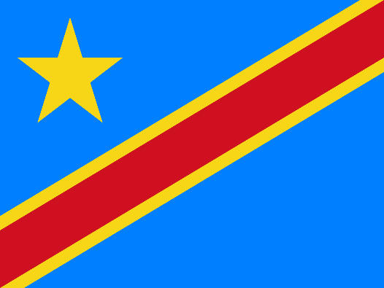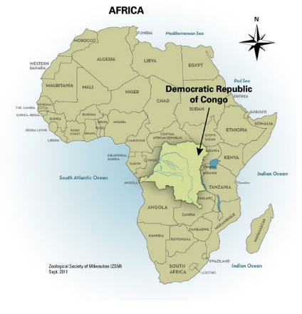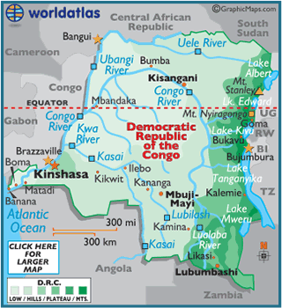
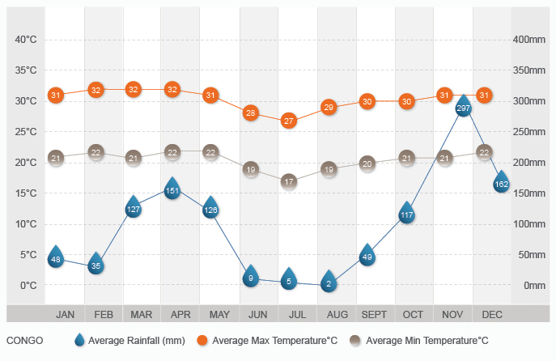
THE FACTS
The Democratic Republic of the Congo (DROC—the former Zaire) is Africa's third-largest country. Its boundaries were drawn arbitrarily at the Conference of Berlin (/topic/Berlin.aspx) in 1884–85. More than 300 ethnic groups speaking between 300 and 600 dialects and languages live within those boundaries. In 1997, Zaire returned to using the name by which it had been known from 1960 to 1970, the Democratic Republic of the Congo. (The DROC was earlier known by the names "The Independent State of the Congo" and "The Belgian Congo.")

Archaeological evidence indicates that this part of the world is one of the oldest places inhabited by humans. Prior to European colonization, the peoples of the DROC were part of empires, kingdoms, and small forest village communities.

At the Berlin Conference, the European powers gave King Leopold II (1965–1909) of Belgium (/topic/Belgium.aspx) sole control of the territory. Leopold ruled it ruthlessly, and forced labour
killed some 10 million Congolese between 1880 and 1910. The horrible realities gained international attention, the Belgian state took over the colony.

However, oppression and exploitation continued through Belgian mining companies. The possibility of revolt forced the Belgians to grant what is now the DROC its independence in 1960. Prime Minister Patrice Lumumba (1925–61), who had socialist leanings (advocating collective rather than private economic ownership), was killed in February 1961. The U.S. Central Intelligence Agency (CIA
(/topic/Central_Intelligence_Agency.aspx)) allegedly was involved, and brought Mobutu Sese Seko (1930–97) to power in 1965. Mobutu stole the country's resources and impoverished his fellow Congolese. His fortune, estimated at over $8 billion, made him possibly the richest man in the world. He was ousted in May 1997 and died in exile later that year. Laurent Désiré Kabila (1939–) then became president.

LOCATION
The DROC is roughly equal in size to the United States (/topic/United_States.aspx) east of the Mississippi River (/topic/Mississippi_ (river_US).aspx). Geographically, it extends from the Atlantic Ocean (/topic/Atlantic_Ocean.aspx) to the snow-capped Ruwenzori Mountains—the fabled "Mountains of the Moon." The mostly highland plateau is broken up by hilly and mountainous terrain, and a vast central basin drains into the Congo River.

Population density varies greatly from extremely dense urban centres to the sparsely populated central basin. Six ethnic groups account for more than 69 percent of the population. These include the Luba, Kongo, Mongo, Rwandese, Azande, and Bangi and Ngale.

The DROC claims the second-largest remaining rainforests in the world. However, deforestation from commercial logging threatens the fragile ecosystem.

LANGUAGE
In spite of the many dialects or languages spoken throughout the DROC, four national languages predominate. These are Lingala, Swahili, Ciluba, and Kikongo. French is officially used in the government, and in education at university and high school levels. In public elementary schools, French is often taught as a second language. It is common to find people speaking a national language at the market, French in school, and their native language at home.

FOLKLORE
Folklore is communicated in many ways, including literature, art, music, and dance. It is a means of carrying on tradition from generation to generation. Each ethnic group has its own legends and folktales, though similarities exist. Animals figure importantly. For example, the rabbit is identified with intelligence and cunning, while the crocodile is associated with something bad, such as an unforgiving traffic cop.

On television, a popular figure, Grand-père (grandfather), tells folktales in a village setting. This is a modern version of an older tradition where storytelling took place around an evening fire. The purpose of the tales is to teach while entertaining. Grand-père frequently explains the morals of these stories and their application to daily life.

RELIGION
Nearly half of all Congolese practice Catholicism, and another third are Protestant. However, Christian and traditional forms of religion are often combined. For example, at holy Mass, ancestors are begged for protection. People dance in the liturgy and offer in kind gifts, including goat, cassava, fish, fruits, and vegetables.

In 1921, Simon Kimbangu (1889?–1951), claiming to be a prophet of Jesus Christ, led a religious revival against colonialism. Some 17 percent of the population now profess a form of African Christianity.

Traditional belief holds that all things have life and deserve respect. This even includes inanimate objects such as rocks. Life never ends, and no separation exists between the living and the dead. Offering the ancestors a drink by pouring some beer on the ground is symbolic of this belief. Nzambe, assisted by the spirits of ancestors, is the Supreme Being from whom all things come.

PEOPLE: Congolese
ALTERNATE NAMES: Congo-Kinshasans
LOCATION: Democratic Republic of the Congo (formerly Zaire)
POPULATION: 45 million
LANGUAGE: Lingala; Swahili; Ciluba; Kikongo; French (language of government)
RELIGION: Christianity (/topic/Christianity.aspx) (Catholicism, Protestantism, African Christian.

5 THINGS YOU MAY NOT KNOW ABOUT THE DRC

1. The DRC is not the same as the ROC
Formerly known as Belgian Congo, Zaire, and a few other names, the current Democratic Republic of the Congo should not be confused with its neighbor, the Republic of Congo. The DRC is a country that’s the size of western Europe and was once a Belgian colony, while the ROC (also known as just Congo, Congo Republic, or Congo-Brazzaville) is a former French colony that’s approximately the size of California.

2. It’s Safe to Travel There — Mostly
The DRC has definitely faced some challenges in the last decade, as civil war ravaged the country. But since 2013 it has been safe to go to the main touristic sites and cities (such as the national parks, Goma, and Kinshasa). However the central government is weak, poverty is rampant, warlords run vast areas of the east and rebel armies duke it out. So stay in safe areas, and if necessary consult your home country’s overseas travel warnings for guidance.

3. There are Eight Active Volcanoes
Nyiragongo Volcano is one of a chain of eight active volcanoes in the country, and one of the world’s most active volcanic areas. It’s a five-hour climb on steep terrain up Nyiragongo Mountain, but for the adventurous who make the trek, the world’s largest lava lake is revealed at the top.

4. The River is EPIC
The Congo River, made famous by Joseph Conrad in his classic 1899 novel “Heart of Darkness,” is the world’s second-largest river by volume, In fact, the river is three miles wide at the point where it runs between Kinshasa and Brazzaville (the capital of the neighbouring Republic of Congo).

5. Automation
Due to its traumatic recent history and economic stagnation, ATMs only began appearing in the DRC in 2010.
MAJOR HOLIDAYS
The increasingly difficult political and economic climate in the DROC has dampened popular celebrations of secular holidays. Until recently, May 20, the day Mobutu's Popular Revolutionary Movement Party (MPR) was founded, was marked by parades and huge celebrations highlighting regional folkloric troupes wearing the party colours.
Independence Day celebrations seemed small in comparison. Christmas (/topic/Christmas.aspx) (December 25), New Year's Day (January 1), and Easter (/topic/Easter.aspx) (late March or early April) are festive occasions. Those who can afford it celebrate with a meal of roasted goat or cow.

Parent's Day, August 1, is a unique holiday. In the morning Congolese celebrate the dead, and in the afternoon, the living. Residents of Kinshasa (/topic/Kinshasa.aspx), for example, go to the cemeteries early to clear and spruce up family graves. Adults then return home to eat again together with the children.

RITES OF PASSAGE
In the DROC, children are a symbol of wealth, and all births are celebrated with joy. However, boys are more desired because they continue the family name. Prior to colonization, boys and girls passed to adulthood through initiation rites. Boys were circumcised and were taught the elders' wisdom and the values of their culture. Girls were never circumcised, but they were taken to a secret place and taught how to succeed in marriage and how to raise a family. Nowadays, male circumcision occurs soon after birth. Because of social changes in the cities, young men and women are usually taught about life and their culture by a family member such as an uncle or aunt.

RELATIONSHIPS
Congolese are extremely friendly. They commonly stop to greet friends, and even strangers, on the street. It is customary to shake hands when meeting people and when taking leave of them. There are several ways to greet people depending on time of day, the nature of the relationship, and so forth. In the morning a Lingala-speaker greets by asking, "Hello, is that you? (Mbote, Yo wana?), Are you awake? (Olamuki?), How did you sleep? (Olalaki malamu?). “Asking someone how they are consists of literally asking, "What news? (Sango nini?). " The typical reply would be, "No news! (Sango te)" meaning, "Fine."

Congolese place great importance on family and social relations. A grandparent affectionately refers to his or her grandchild as "little husband or wife," and the grandchild refers to the grandparent in the same way. A woman light-heartedly addresses a neighbour as "father-in-law" (bokilo) because she likes his young son, whom she calls her "little husband." Many people call friends and even strangers "brother-in law" or "sister in-law." This serves to build friendships and avoid conflict.

LIVING CONDITIONS
For the majority of Congolese, living standards are low. Political instability and rising inflation increase the cost of basic goods practically by the hour. Consequently, goods in the market are priced in U.S. dollars. A typical good-humoured response to the question "How's it going?" has become, Au taux du jour! meaning, “according to the daily rate!"

Homes in the village are often made from mud brick, and thatch or galvanized-iron roofing. They are clean but not mosquito-proof. In the towns, some houses have electricity, running water, and flush toilets.

FAMILY LIFE
Families tend to be large, with as many as ten or more children. Parents invest what they can in their children. In return, children are expected to take care of their parents when they reach old age. The number of children per family is shrinking, especially in urban centers. Polygyny (more than one wife) is practiced, but second wives are not recognized by the state or by the Church.
A couple often participates in three marriage ceremonies: traditional, civil, and religious. The traditional ceremony consists of exchanging gifts between the two families. The civil ceremony consists of exchanging wedding vows before a government representative. Finally, at the church, the bride might wear a Western-style wedding dress for the religious ceremony. In rural areas, wedding celebrations can last weeks, punctuated with singing, dancing, and feasting.

CLOTHING
In the DROC, people dress up, even when going to work. If they lack the means to buy fancy clothes, they wear washed and neatly pressed clothing bought second-hand. In the 1970s, the government banned Westernized business suits for men. They were replaced with collarless suits, or abacost, meaning "down with suits." Neckties and bow ties were replaced with scarves and matching handkerchiefs in the front pockets.

Traditionally, women were not permitted to wear wigs, Western pants, jeans, or miniskirts. Even today as these rules are overturned, women prefer African wraparounds (pagnes), tailored in creative styles with bright African patterns. Women with the means wear made-to-order jewellery of ivory, malachite, gold, silver, copper, and diamonds.

FOOD
Congolese love to eat. Staples in their diet include cassava, rice, potatoes, plantains, and sweet potatoes or yams, accompanied by a sauce of greens, fish, or meat, depending on the region. The DROC is perhaps best known for mwamba, a sauce made of palm-nut paste, in which chicken, meat, and fish are cooked. Mwamba is eaten with rice, fufu (similar to a dumpling), or chikwange (cassava prepared in banana leaves).

Other traditional foods include pounded sesame seeds (wangila), squash seeds (mbika), steamed chicken or fish (maboke), shiska-bobs (kamundele), and plantain dough (lituma). In some regions, people consider caterpillars, grubs, roasted crickets, and termites to be delicacies.

Near the equator, wild game such as elephant, monkey, hippopotamus, and crocodile are enjoyed. The Congolese fondness for beer is legendary. However, in the villages, palm wine is the favourite.

EDUCATION
About 72 percent of Congolese are able to read and write, due to a strong elementary school system. Education is not required by law, but 90 percent of all Congolese children attend primary school for at least a few years. Many children drop out at times to work when parents are unable to pay admission fees and other expenses.

A unique Congolese tradition is salongo, which brings all the students together on Saturday afternoons to clean up the school yard and remove weeds and brush.

Secondary school begins with a two-year middle school program. A high school diploma must be earned by passing a rigorous state exam. Public university, plagued by political and social problems, closes frequently. Currently, Congolese are trying to solve their problems by creating privately funded and administered universities.

CULTURAL HERITAGE
Congolese modern dance music has been popular throughout sub-Saharan Africa since the 1950s. Referred to as "Sukus" in the United States, it continues to gain international popularity. The dance is to music that combines jazz, traditional tunes, and Latin influenced rhythms. The instrumentation consists of electric guitars, keyboards, trumpets, saxophones, conga drums, and Western-style drum sets. Lyrics in Lingala comment on society, give advice, make political statements, criticize behaviour, or simply relate love stories.

Congolese are imaginative dancers, constantly inventing new dances that come and go almost monthly. Drumming and dancing are part of any festive occasion. The national folkloric ballet has gained an international reputation.

From ancient times, Congolese peoples have used their oral literature to carry on traditions, customs, and social values. Modern written literature has been built on this oral foundation. It varies widely from classical to popular forms, and is written in French as well as in national languages. Drama is one of the most popular forms of literature today.

EMPLOYMENT
Among the greatest challenges facing the DROC are the rebuilding of its crumbling factories and mining operations, and creating jobs for its citizens. At least 75 percent of the people still work in subsistence agriculture; they produce only a little more than what is needed for personal use.

Industry employs only 13 percent of the work force, mainly in copper smelting, metal production, timber extraction, oil palm processing, textiles, chemicals, and food processing. Services employ about 12 percent of the labour force.

SPORTS
Soccer is the national pastime, played or watched virtually throughout the country. Competition with African national teams is intense. When the DROC national team defeated the Moroccans for the Africa Cup in the 1970s, the returning players were welcomed like royalty and given houses, cars, and large sums of money by the government. Congolese were treated to a national holiday.

People love playing cards, chess, checkers, and board games. A traditional board game called Mangula is played mainly in rural areas by men. Mangula Equipment a carved wooden board with two rows of shallow pockets separated by a divider, or an empty egg carton and about 36 small stones. Directions:
1. Place a few small stones in each shallow pocket in the board.
2. Player One moves and continues according to the number of stones he picks up. Each time he lands, he picks up his opponent's stones in the pocket opposite him across the divider, and uses these stones to continue his play.
3. When he fails to pick up any stones, his opponent takes his turn. The first person to move all his opponent's stones to his side of the board wins.

RECREATION
Besides playing and watching soccer, people in towns love watching television dramas. Cinemas are also popular and are found in most towns, as are satellite dishes and videos. Although American and world cultures are becoming more popular, people still love Congolese music and dance. Young people and adults enjoy going out on Saturday night to socialize, listen to music at outdoor pubs, dance at nightclubs, and watch theatrical events.

CRAFTS AND HOBBIES
The DROC is famous for its traditional folk art and crafts. Artists and craftspeople produce ceramic pots, reed mats, woven baskets, woodcarvings, chess games, sand paintings, handmade clothing, and jewelry. In general, African art is functional, but increasingly art produced for tourists generates income. Masks were traditionally assigned power to communicate with the divine. Some are still only brought out on very specific occasions for initiations and for solving community problems.

The Bakuba people from the Kasai regions still produce wood sculptures, masks, and statuettes that may be used to increase fertility and to chase away evil spirits. In recent times, a distinct style of oil painting has emerged that reconnects the magnitude of contemporary social challenges. In these paintings, snakes or lions within striking distance of unsuspecting human prey depict impending doom.

SOCIAL PROBLEMS
Congolese must conquer hunger, political repression, and political and economic instability, and meet their basic daily needs. People work hard for very little. Many people resort to debrouillez-vous, which means "make do in whatever way possible."

Children leave school early, girls prostitute themselves, civil servants steal, police officers take bribes, and military personnel loot and pillage. Enormous human losses caused by human immunodeficiency virus/acquired immune deficiency syndrome (HIV/AIDS) and the Ebola virus challenge Congolese to care for the sick and orphaned. A hidden tragedy is that generations of Congolese children may be growing up undernourished on a basic diet of cassava, which is extremely poor in nutrition.

